

**OPERATING SYSTEM PROJECT**

**SLEEPING BARBER**

**PROBLEM**

**Group Members:**

1. Bilal Ahmed Khan (20k-0183)
2. Zulnoor Siddiqui (20k-1090)
3. Wamiq Akram (20k-1857)

**Abstract:**

This Project intends to apply the concepts learnt in Inter-Process communication to solve the Sleeping Barber Problem.

**Problem Statement:**

The analogy is based upon a hypothetical barber shop with one barber. There is a barber shop which has one barber, one barber chair, and n chairs for waiting for customers if there are any to sit on the chair.

* If there is no customer, then the barber sleeps in his own chair.
* When a customer arrives, he has to wake up the barber.
* If there are many customers and the barber is cutting a customer’s hair, then the remaining customers either wait if there are empty chairs in the waiting room or they leave if no chairs are empty.

**Program Structure:**

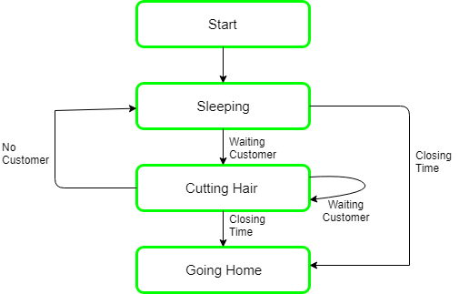

**Technologies used in the Project:**

1. Linux Operating System
2. VmWare virtual machine

**THE END**